PROJECT
MACHINE LERANING

MARKET BASKET ANALYSIS WITH PYTHON – AMAZON

PREPARED BY – AKRITI TRIPATHI
COURSE- 15TH DECEMBER
(DATA SCIENCE)

OBJECTIVE

The main objectives of this project are:
1-To analyze customer purchasing behavior using real world Amazon data
2-To identify products that are frequently purchased together (Market Basket Analysis)
3-To perform data cleaning and preprocessing for accurate analysis
4-To understand customer demographics and buying patterns
5-To segment customers based on their purchase frequency and satisfaction levels
6-To evaluate the impact of reviews and recommendations on customer satisfaction
7-To provide actionable insights for improving business strategies.

Tools & Technologies Used

1- Python
2- Pandas & NumPy (Data Processing)
3-Matplotlib & Seaborn (Data Visualization)
4-Scikit-learn (Clustering – K-Means)
5-Jupyter Notebook

Key Findings
1-High shipping costs are a major reason for cart abandonment.
2-Most customers fall into the “Occasional Shoppers” category.
3-Customer satisfaction is directly linked with recommendation quality.
4-Product categories with high demand offer strong cross-selling opportunities.
5-Reviews and ratings significantly influence purchasing decisions.
Task 1: Data Cleaning and Preparation
This is the most important step in any data analysis project. Raw data is often messy, incomplete, and inconsistent. Before performing any analysis, it is necessary to clean and prepare the data to ensure accuracy.
WHAT WAS DONE-
1-Removed duplicate records to avoid repetition.
2-Standardized categorical values (e.g., “Male”, “male” treated same).
3-Handled missing values using mean/mode methods.
4-Renamed columns to remove spaces and formatting issues .
5-Converted important columns (like satisfaction ratings) into numeric format.

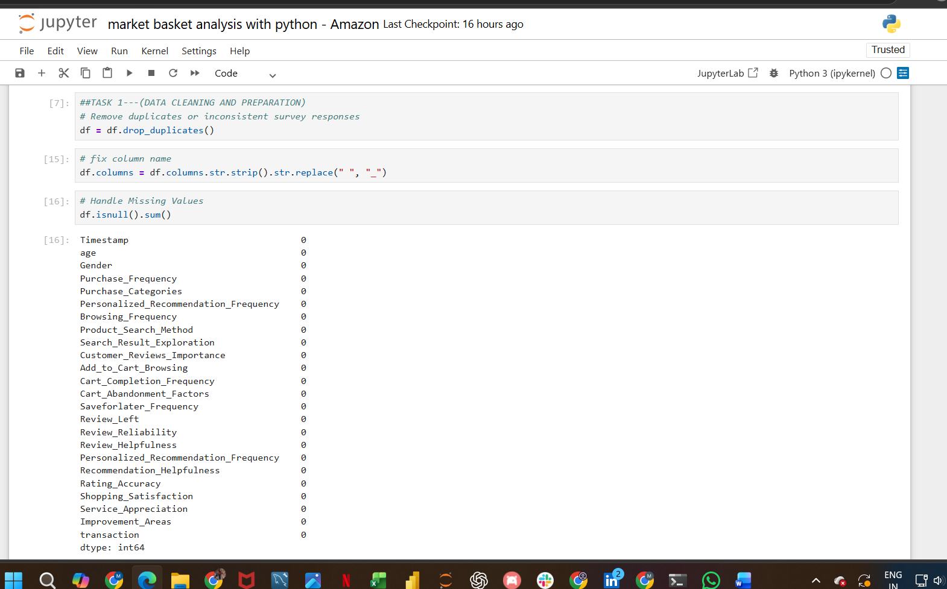
Task 2: Descriptive Behavior Analysis
This step focuses on understanding customer behavior using basic statistical analysis and visualization.
What was analyzed:
- Customer demographics (age, gender distribution)
- Purchase frequency (weekly, monthly, etc.)
- Popular product categories
- Browsing methods used by customers
- Cart abandonment reasons
- Average satisfaction and rating accuracy
Key Insights:
- Many customers shop occasionally rather than frequently
- High shipping cost is a major reason for cart abandonment
. Some product categories have higher demand than others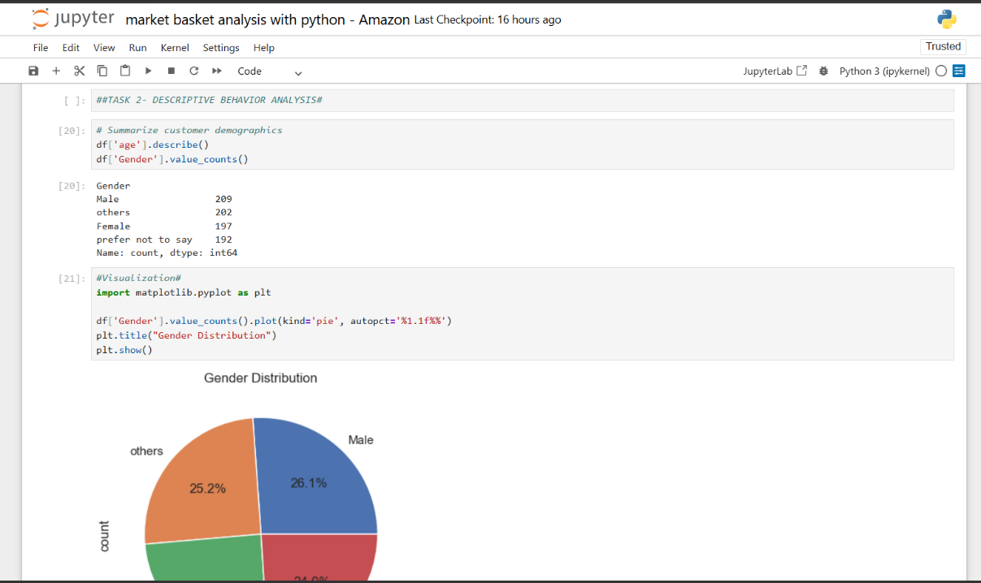
Task 3: Customer Segmentation and Profiling
In this step, customers are divided into different groups based on their behavior. This helps in targeted marketing.
Segments Created:
- Frequent Buyers: High purchase frequency and high satisfaction
- Occasional Shoppers: Moderate activity
- At-Risk Customers: Low satisfaction or low engagement
Techniques Used:
- Rule-based segmentation
- K-Means Clustering (Machine Learning)
Key Insights:
- A large number of customers fall into the “Occasional” category
- Some customers are at risk due to low satisfaction
- Clustering helps identify loyal vs risky customers

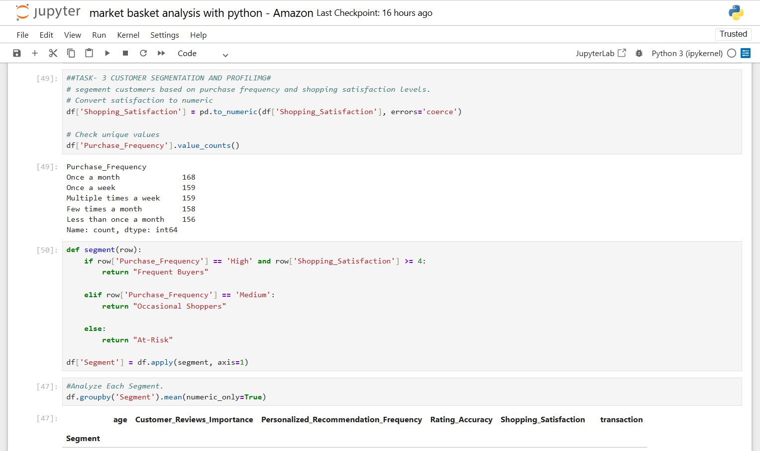

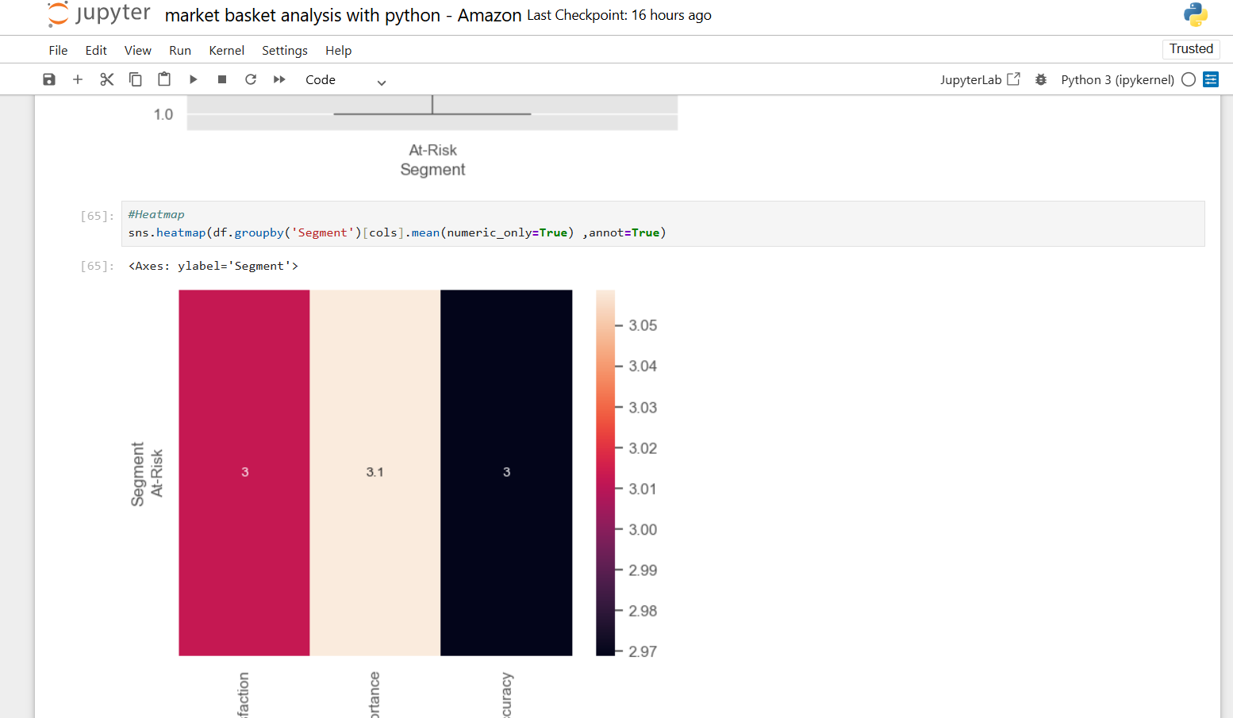

Task 4: Recommendation and Review Insights
This step analyzes how recommendations and customer reviews affect satisfaction.
What was analyzed:
- Relationship between recommendation helpfulness and satisfaction
- Impact of customer reviews on purchasing decisions
- Importance of rating accuracy
🔹 Key Insights:
- Better recommendations → higher customer satisfaction
- Reviews play a major role in decision-making
- Accurate ratings increase customer trust
- 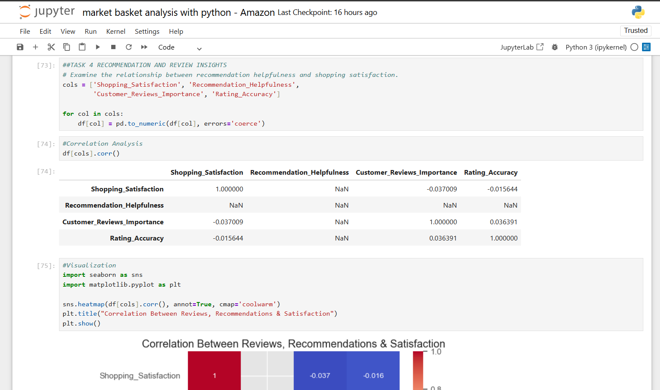
- 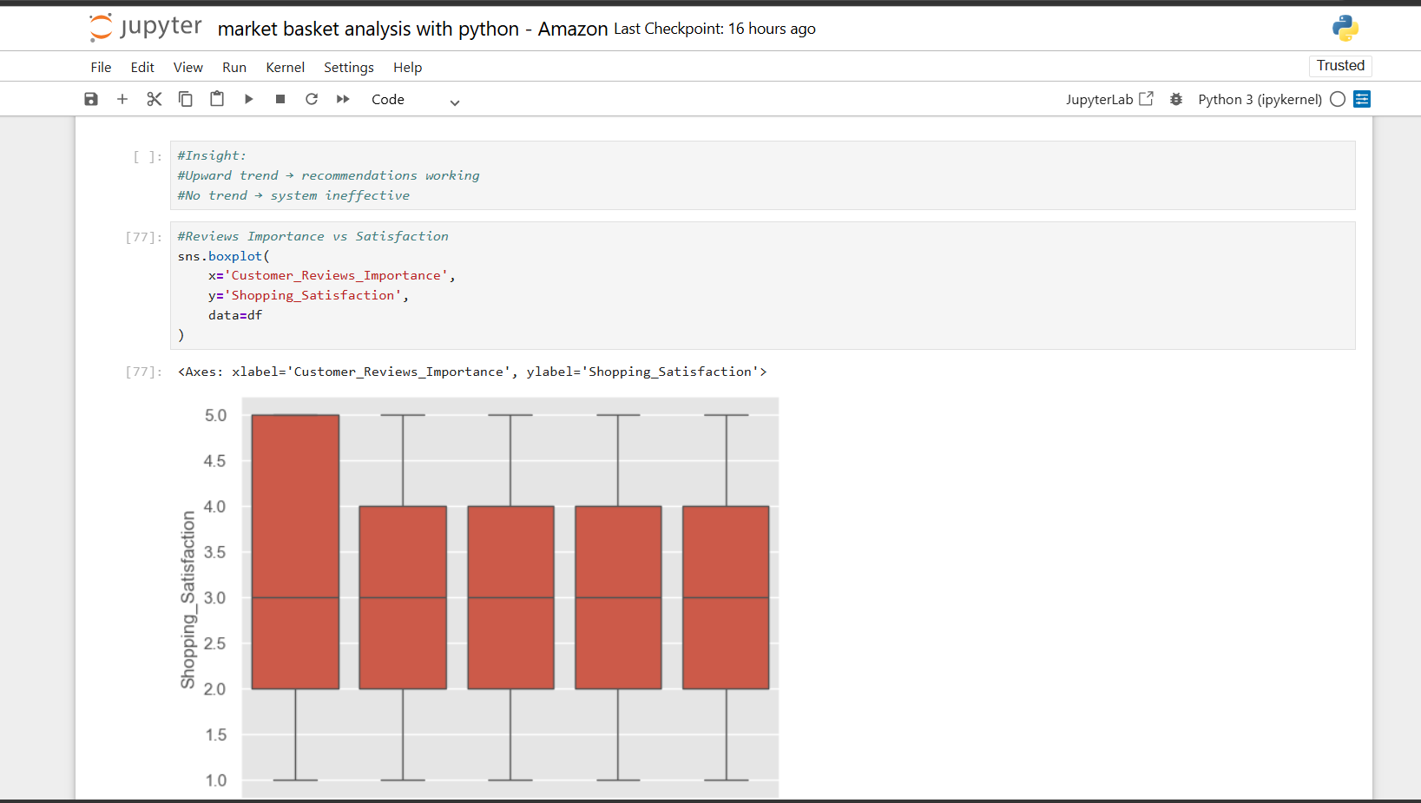

Task 5: Visualization and Reporting
Data is presented visually to make insights easy to understand.
Visualizations used:
- Bar charts (product categories, purchase frequency)
- Pie charts (customer distribution)
- Histograms (satisfaction levels)
- Heatmaps (correlation analysis)
Key Insights:
- Majority customers are occasional buyers
- Certain categories dominate sales
- Satisfaction levels vary across customers
- 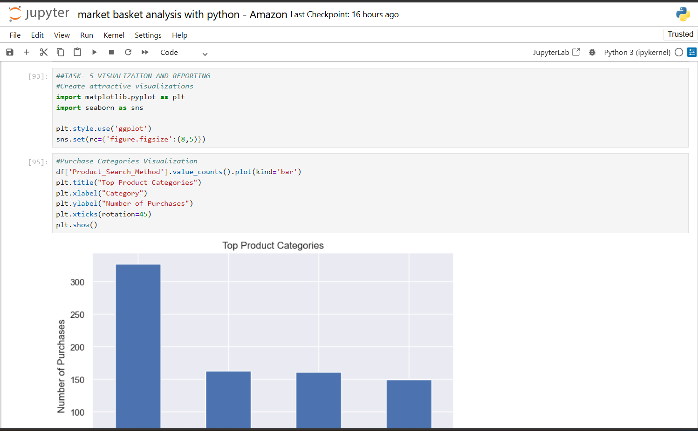
- 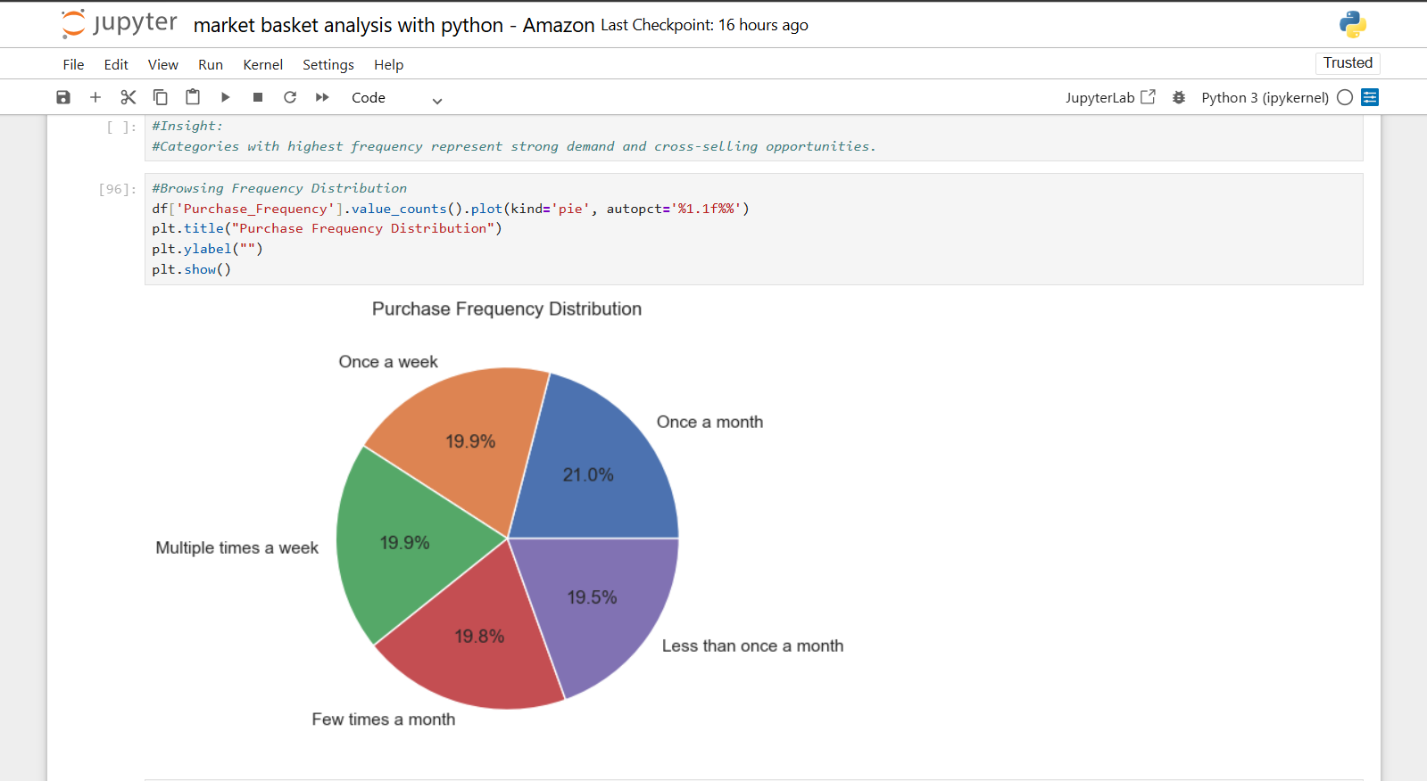
- 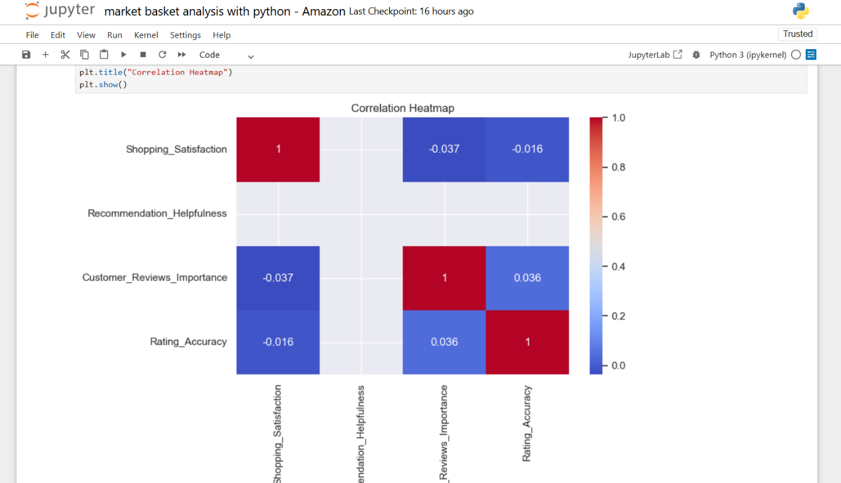

Conclusion
This project successfully demonstrates how data analytics can be used to understand customer behavior in e-commerce. Market Basket Analysis helps in identifying product relationships, while customer segmentation allows businesses to target the right audience effectively.
The insights generated can help Amazon (or any e-commerce platform) improve customer engagement, enhance recommendation systems, and increase overall sales.
All tasks together help in understanding customer behavior deeply. From cleaning data to generating insights and presenting them, each step plays a crucial role in making data-driven decisions in e-commerce.

SUMMARY OF THE PROJECT

This project focuses on analyzing customer purchasing behavior on Amazon using data analytics techniques in Python. The aim is to identify patterns in customer transactions, understand product relationships, and generate insights that can improve business decision-making.
The analysis includes data cleaning, exploratory data analysis, customer segmentation, and recommendation insights. By applying techniques such as Market Basket Analysis, clustering, and correlation analysis, the project highlights how customers interact with products and what factors influence their purchasing decisions.
The findings help in identifying frequently purchased product combinations, customer satisfaction levels, and key factors affecting cart abandonment. These insights can be used by businesses to improve marketing strategies, enhance customer experience, and optimize inventory management.

My project explanation link
https://www.loom.com/share/5f5c015f10714741bdb2631272d74677

